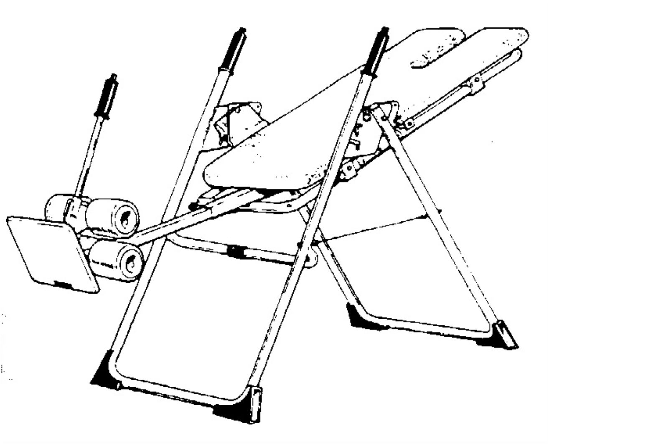

The effect of the Mastercare back-a-traction in combination with exercise therapy on
chronic low back pain.

Practical Part

A study executed from January till March 2003.

Copromotor : K. Timmermans

